Experiment 4

Aim: To implement histogram equalization on a given image and compare it with the original image using OpenCV.

Algorithm
- Import OpenCV.
- Read the input image.
- Convert the image into grayscale.
- Apply histogram equalization using equalizeHist().
- Display the original grayscale image.
- Display the histogram-equalized image.
- Close all windows.

Program
import cv2
img = cv2.imread("image.jpg")
gray = cv2.cvtColor(img, cv2.COLOR_BGR2GRAY)
equalized = cv2.equalizeHist(gray)
cv2.imshow("Original Image", gray)
cv2.imshow("Equalized Image", equalized)
cv2.waitKey(0)
cv2.destroyAllWindows()
Output
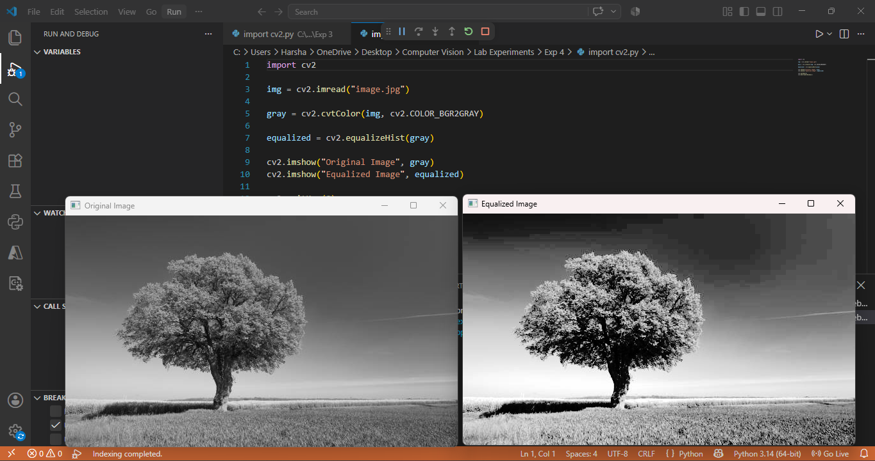

Result: Thus, histogram equalization was successfully implemented and the contrast of the image was improved.

